Jerahmeel Calma www.github.com/jmcalma/CS380-EX6

Logging in as ted without providing a password

To log in as “ted” without providing the correct password or typing anything in the password field, I typed ted’);# in the username field. Since the username field in the php file is saved in the $user variable which is concatenated to the SQL query, I am able to trick the form into logging me into ted’s account. In SQL syntax, the # is the character that creates a single line comment. The # comments out the code in the php file after the WHERE (name = '$user'

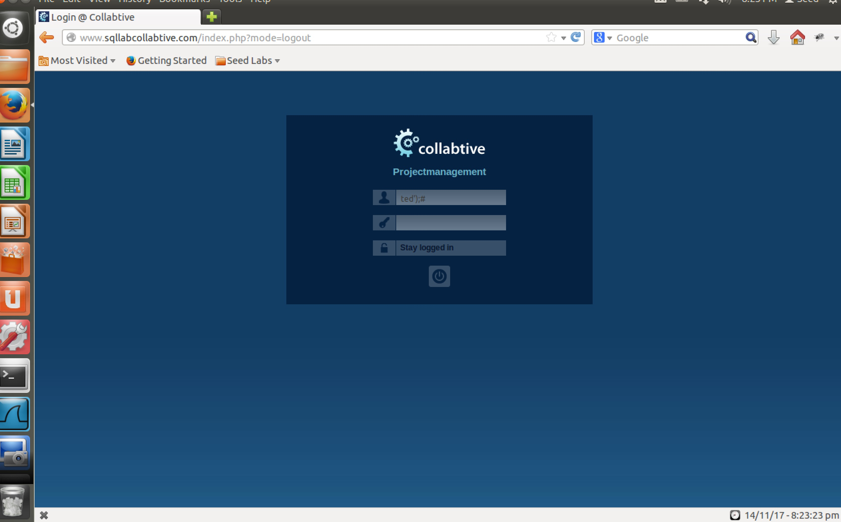
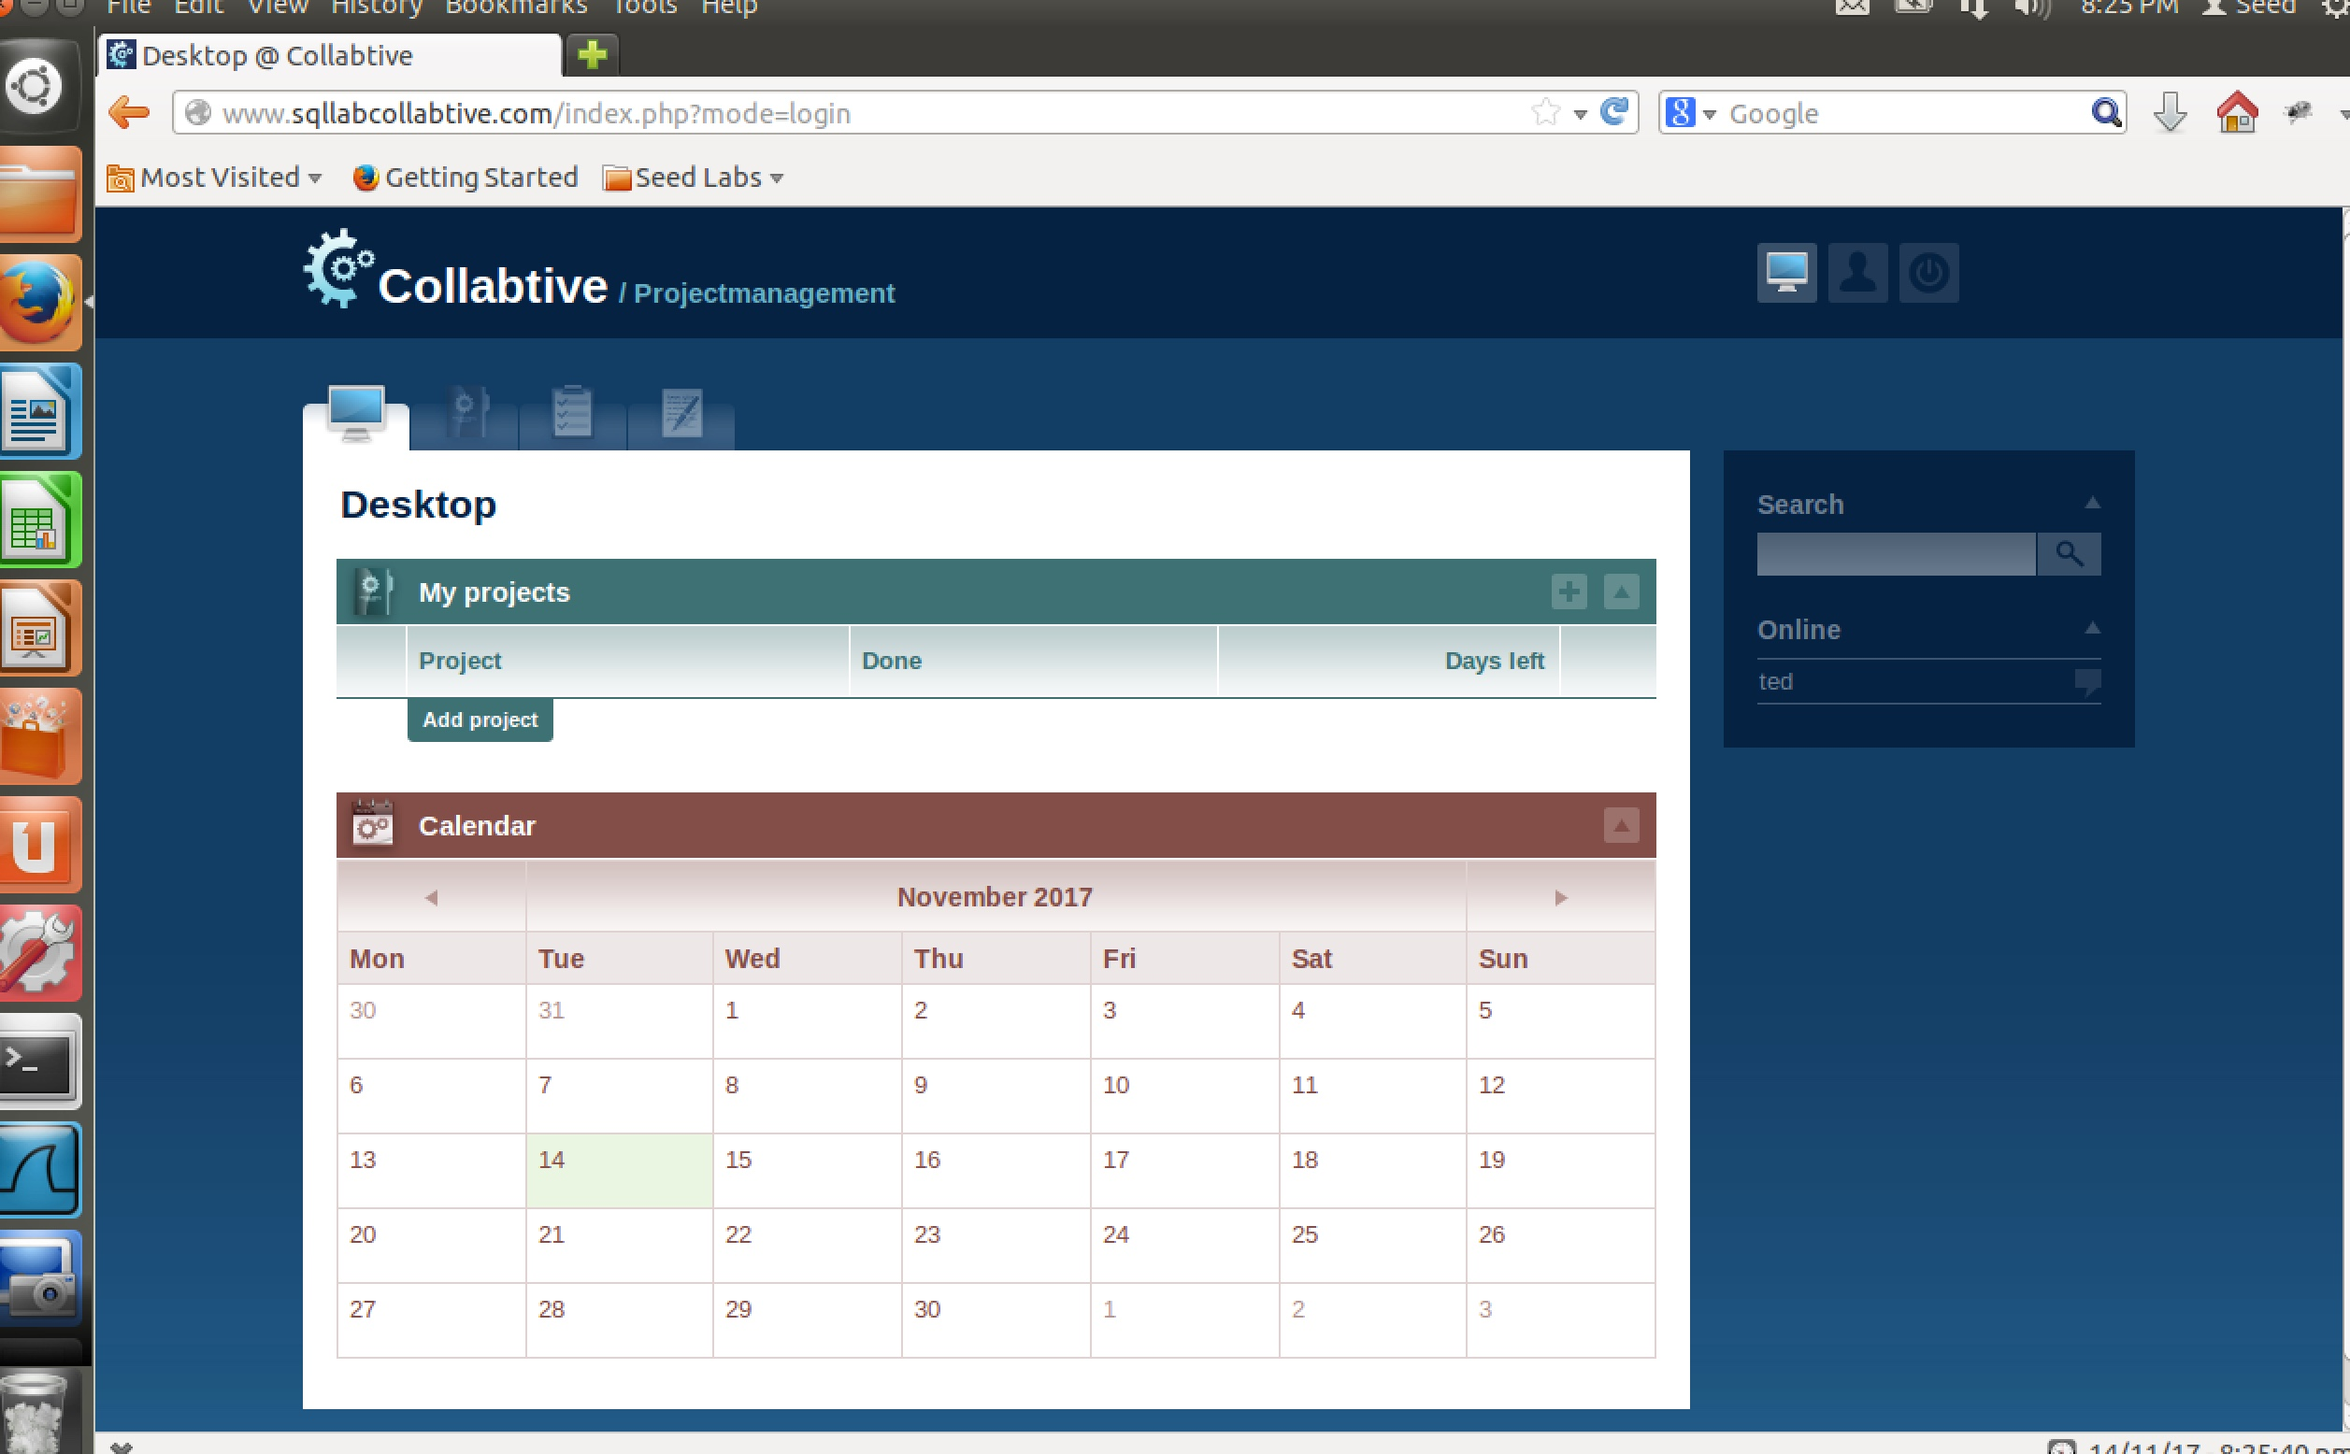
Logging in as admin without providing a password

To log in as “admin” without providing the correct password or typing anything in the password field, I used the same approach as trying to log in as “ted”. I replaced ted and put admin, so my injected code was admin’);#

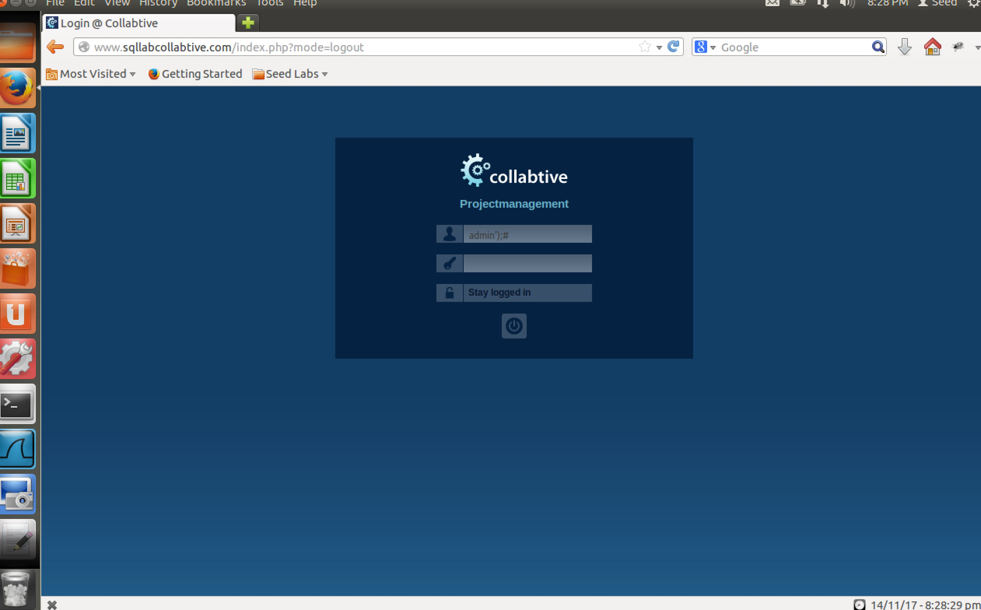

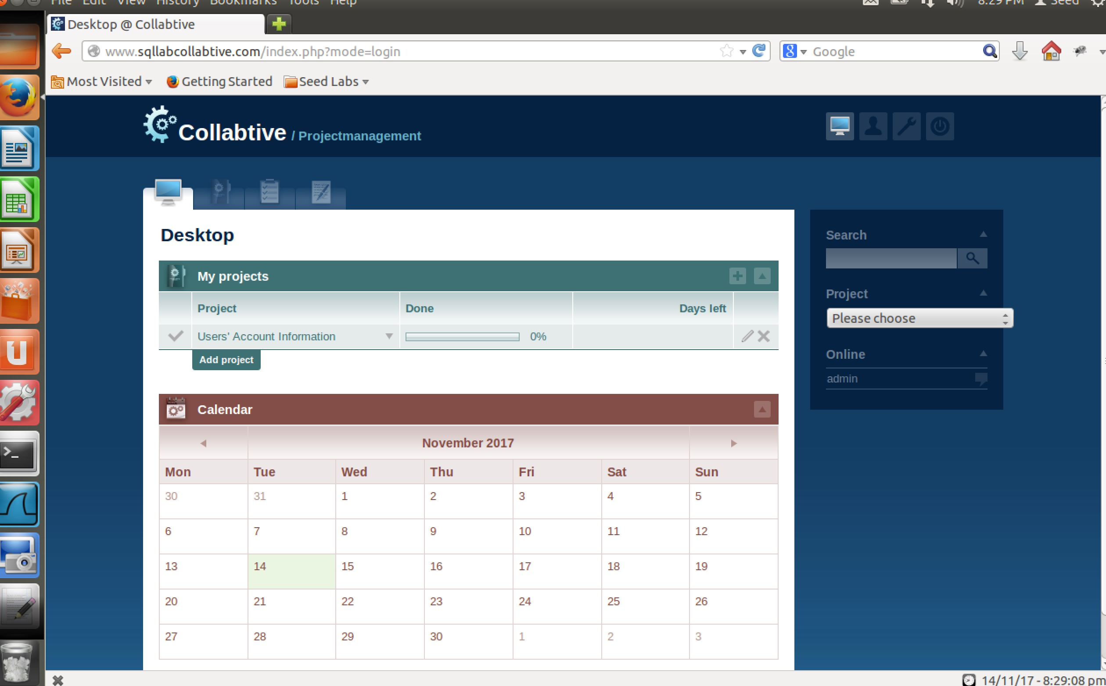
Logging in without providing a username

To log in to an account without providing a username or password, I typed the following in the username field: ’ OR TRUE);#
In the code I injected, the quotation mark is meant to close the opening quotation mark in front of the variable $user. I used the OR operator with the boolean value TRUE so that I can make the SQL query true and log me into an account. The SQL injection logs me into the “admin” account which I think is the default account for the website.

